**Multi - Dimensional Data Model:**

* The multi-Dimensional Data Model is a method which is used for ordering data in the database along with good arrangement and assembling of the contents in the database.
* OLAP (online analytical processing) and data warehousing uses multi dimensional databases. It is used to show multiple dimensions of the data to users.
* It represents data in the form of data cubes. Data cubes allow to model and view the data from many dimensions and perspectives.
* These data cubes consist of dimensions and facts, with facts being numerical measures stored in a fact table that links to related dimensional tables.

**Diagram:**

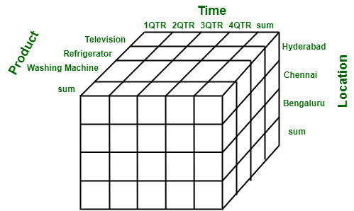

**Working on a Multidimensional Data Model:**

1. **Collect Data from the Client**: Gather all relevant data from the client. Professionals guide the client on what data can be effectively managed with the chosen technology.
2. **Organize Data Segments**: Sort and classify the collected data into different categories, making it easier to process step by step.
3. **Identify Dimensions**: Determine the key factors (called dimensions) that define the system, based on the user's perspective. These could include categories like time, location, or product.
4. **Define Attributes**: For each dimension, identify specific details or qualities (attributes) that describe it, like months for the time dimension or cities for the location dimension.
5. **Validate and Differentiate**: Ensure the factors and their attributes are accurate and relevant. This step helps refine the data model.
6. **Create the Schema**: Use the organized data and identified dimensions to design a schema, which acts as the blueprint for structuring the data in the system.

**For Example :**

***Example 1***Consider a factory in Bangalore selling products each quarter. A 2D table might show sales data organized by:

* Time Dimension: Divided into quarters (e.g., Q1, Q2, Q3, Q4).
* Item Dimension: Types of items sold.
* The fact here is the revenue in rupees (in thousands***).*** 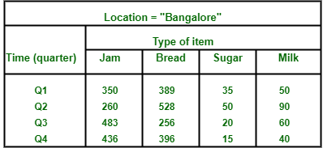

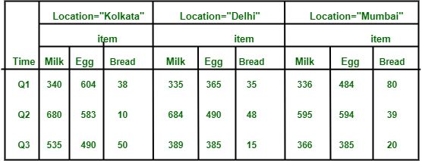

***Extending to 3D:***To include another dimension, like location, sales data from cities like Kolkata, Delhi, and Mumbai can be added. This transforms the data into a 3D table, where sales data is categorized by:

* Item: Types of products.
* Time: Quarters.
* Location: Cities.

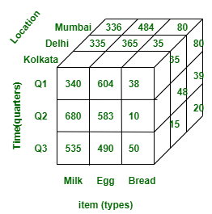

**Key Components:**

**Cubes:** Cubes are structures that represent the multidimensional relationships between measures and dimensions in a data model.

**Hierarchies:**Hierarchies are a way of organizing dimensions into levels of detail.

**Dimensions:** Dimensions are attributes that describe the measures, such as time, location, or product.

**Aggregation:**Aggregation is the process of summarizing data across dimensions and levels of detail.

**Measures:** Measures are numerical data that can be analyzed and compared, such as sales or revenue. They are typically stored in fact tables in a multidimensional data model.

**Advantages of Multi-Dimensional Data Model**

1. **Ease of Use**: It is straightforward to manage and maintain.
2. **Enhanced Performance**: Performs better than traditional relational databases for analytical tasks.
3. **Better Data Representation**: Provides a multi-view perspective, capturing various factors and dimensions.
4. **Handles Complex Systems**: Suitable for complex systems and applications, unlike simpler database models.
5. **Improved Compatibility**: Ideal for projects with limited resources for maintenance, as it reduces strain on staff.

**Disadvantages of Multi-Dimensional Data Model**

1. **Complexity**: Requires skilled professionals to analyze and manage the data.
2. **System Vulnerability**: Performance can degrade significantly when system caching issues occur.
3. **Dynamic Design**: The inherent complexity leads to constantly evolving database structures.
4. **Complicated Processes**: Achieving the desired outcome can be a challenging and lengthy process.
5. **Security Risks**: The large number of interconnected databases makes the system more vulnerable to security breaches.